📘 Chapter 1: What is TypeScript?

### ***What is TypeScript?***

TypeScript is a superset of JavaScript that adds static typing.

TypeScript lets you add types to variables, function arguments, return values, and objects, so you can catch mistakes while coding instead of at runtime.

It makes the codebase easier to read, refactor, and scale, especially when a project starts growing big.

And since it compiles down to regular JavaScript, there’s no issue running it in the browser or on Node.

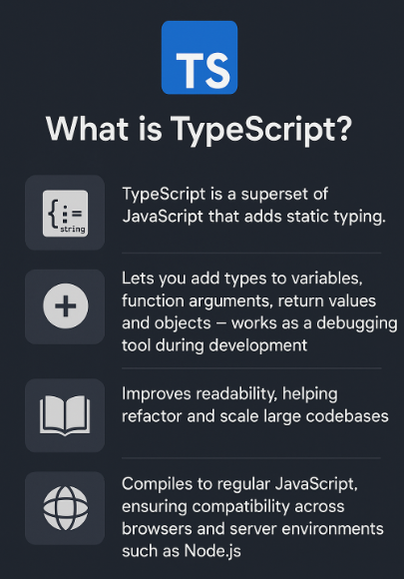

***Example (Your First TypeScript code) –***

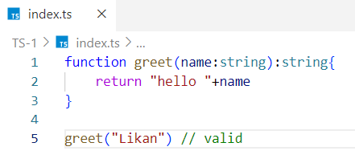

* name: string ensures that the function only accepts strings
* : string after the function means the return value is a string

***Compiling Typescript code into JavaScript code* -**

When a user runs *tsc index.ts*, the TypeScript compiler generates a plain index.js file. This .js file contains the same logic but with **all type annotations stripped out,** because **browsers don’t understand TypeScript, they only understand JavaScript.**

The compiler’s job is to **remove all the TypeScript-specific syntax** (like type annotations, interfaces, enums, etc.) and output clean JavaScript that works in any environment like a browser or Node.js.

***JavaScript code -***

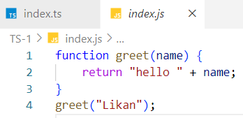

The types are removed in the compiled output. TypeScript vanishes at runtime.

***Real-World Analogy -***

Writing JavaScript is like driving without seatbelts - you're fast, but vulnerable.  
Writing TypeScript is like driving with full safety features - you're still fast, but safer and more confident.

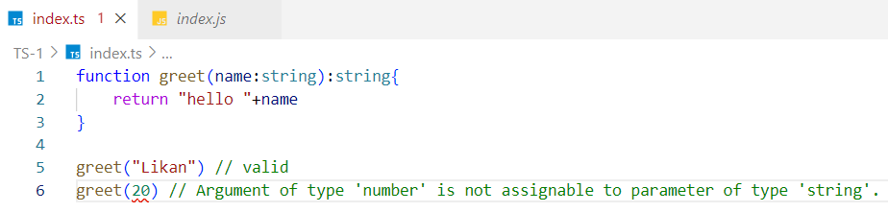

***TypeScript adds safety and tooling to JavaScript.***

In JavaScript, Function parameters are **dynamically typed**, meaning JavaScript doesn’t check what type of value is passed.

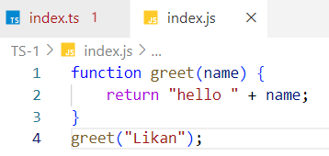

This is **risky** because:

* You might get **unexpected behavior**.
* No **error is thrown**, even if the argument is wrong. I can pass a number as a name
* Bugs might appear **only at runtime**, which is harder to debug.

In **TypeScript**, you can specify that name must be a string:



✅ TypeScript **catches the error early** (at compile time) - this is **safety**.

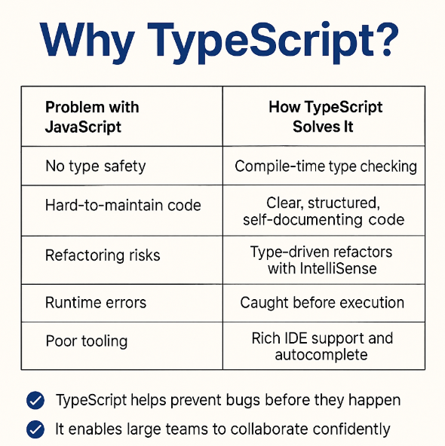

***1.How Typescript makes code easier to maintain?***

Typescript catch early at compile time



***2. Runtime Errors - In JavaScript, many bugs are only found when you run the code.***

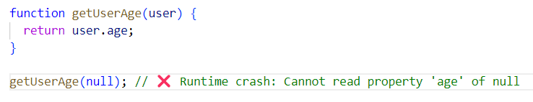

TypeScript catches the problem **before your code runs.**

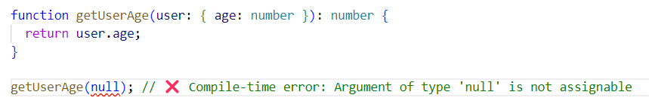

***3. Poor Tooling -***

In JavaScript, your editor doesn’t always know what you're working with so autocomplete, hints, and navigation are limited.

In JavaScript



### In TypeScript

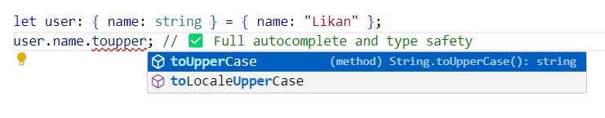

✅ Your IDE now gives

* Autocomplete
* Parameter hints
* Documentation
* Warnings if you make mistakes

***4. Refactoring Risk***

**Refactoring** means changing names or code structure **without breaking** the functionality. Like

* Renaming a variable
* Renaming a function parameter
* Splitting code into smaller pieces

## *💥 What is Refactoring Risk?*

In **JavaScript**, when you change a name, there's **no system to warn you** if you forget to update it in all places.  
In **TypeScript**, the compiler + IDE **alerts you** and even helps you change it **safely everywhere.**

### ***JavaScript Example - Risky Refactor (with inline explanation) -***

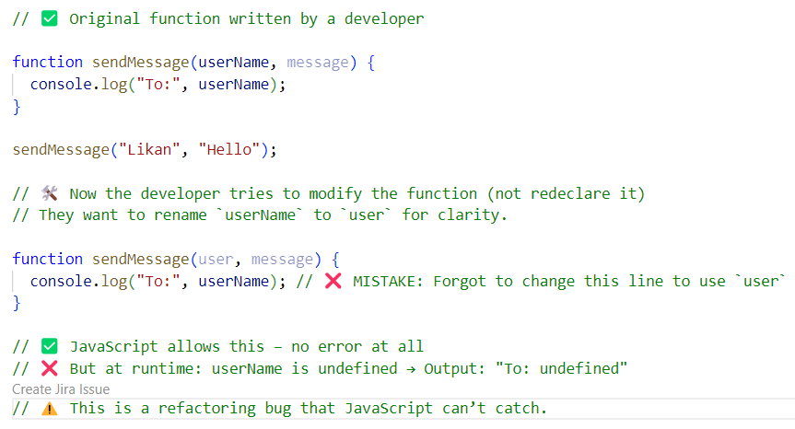

### ***TypeScript Example – Safe Refactor (with inline explanation)***

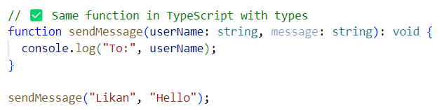

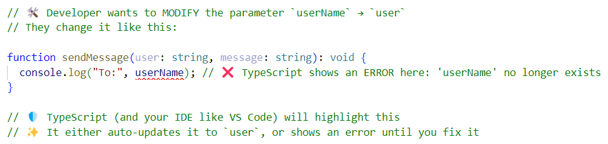

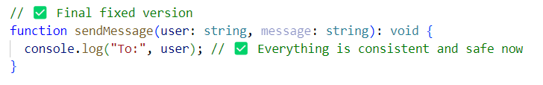

**Note -**

* We are **modifying** the function during refactoring. JavaScript won’t warn you if you mess it up.
* TypeScript + your editor will **catch the mistake instantly**.

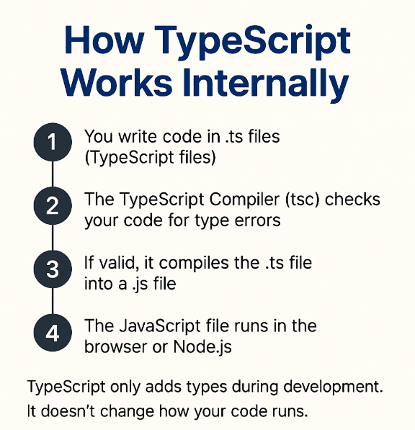

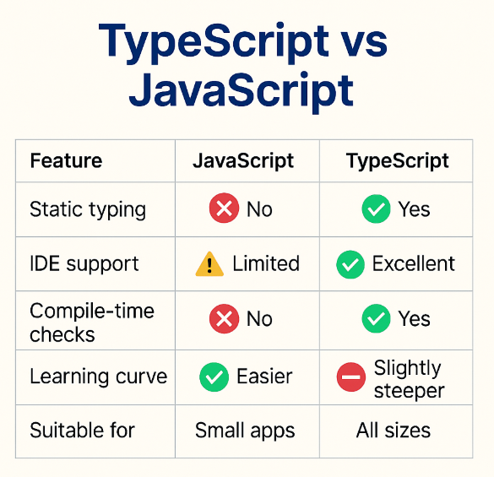

🧠 Interview Insight

**Q: Why use TypeScript in a project?**

* Catches errors early: TypeScript finds bugs while coding, before the code even runs — reducing runtime crashes.
* Improves code quality & readability: Strong typing makes your code clearer and easier to understand, even for new team members.
* Boosts developer productivity: With intelligent autocompletion, type hints, and instant feedback, developers code faster and make fewer mistakes.
* Enables safe refactoring: When you rename or change logic, TypeScript instantly points out affected parts — making refactoring safe and confident.
* Creates self-documenting code: Types themselves act as built-in documentation, showing what each variable, function, and object expects — no need for extra comments.

**Common Follow-up Questions**:

* Does TypeScript run in the browser? (❌ No, only JavaScript runs)
* Is TypeScript faster? (❌ Not in execution, but faster in development)
* Is it a replacement for JavaScript? (❌ No, it enhances JavaScript)

## Q: Is TypeScript faster?

**❌ No, TypeScript does not make your code run faster in the browser.  
✅ But it makes you work faster while writing code.**

## Q: ****What does "self-documenting code" mean in TypeScript?****

**Self-documenting code** means the code **explains itself** you don’t need extra comments or documentation to understand what it does.

### ***In JavaScript (Not self-documenting) -***

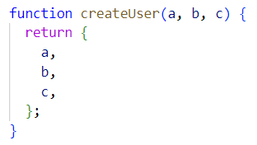

What is a, b, c? Are they strings? numbers? What does this function return?

### ***In TypeScript (Self-documenting)***

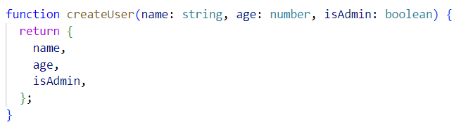Just by looking at the function:

* You know exactly what each parameter means
* You know their types
* You know what the function returns

✅ That’s **self-documenting** - the code explains itself without needing comments

TypeScript adds self-documenting code by making types visible, so other developers can understand your code easily without reading extra docs.